**Inclass Programming Assignment - 1**

**Github Link:** <https://github.com/Viditha2277/CS-5720/tree/main/Assignment%201>

**Problem 1.1:** To take a string as a list of characters from the console, delete at least 2 characters, reverse the resultant string, and print it.

**Input:** String

**Output:** String

**Solution:**

1. The user string is taken, stored in the “initial_string” variable and converted into a list of characters using the list() method.

2. The last two characters were deleted using the string-slicing operator and stored in the "final_string" variable.

3. Then the string is printed in reverse order.

**Code:**

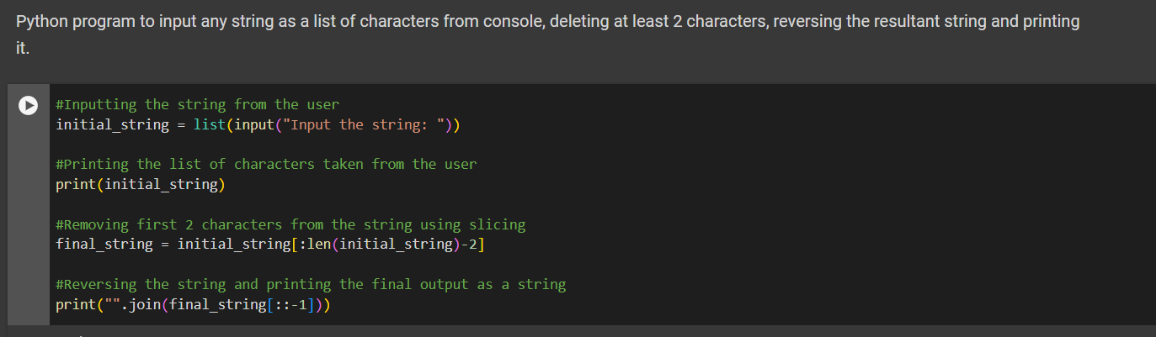

**Output:**



**Problem 1.2:** To input two numbers from the user and perform at least four arithmetic operations on them.

**Input:** Two integers

**Output:** A series of outputs corresponding to its arithmetic operation

**Solution:**

1. Two integers are taken from the user.

2. Five arithmetic operations are performed on the numbers taken from the user.

3. The output for the operations is printed on the console.

4. str(string) method converts any data type into string data type which is further concatenated with other strings in the print function.

**Code:**

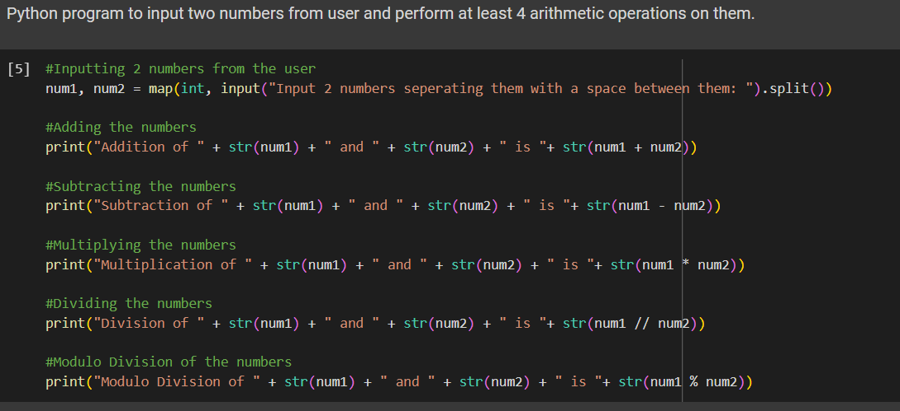

**Output:**

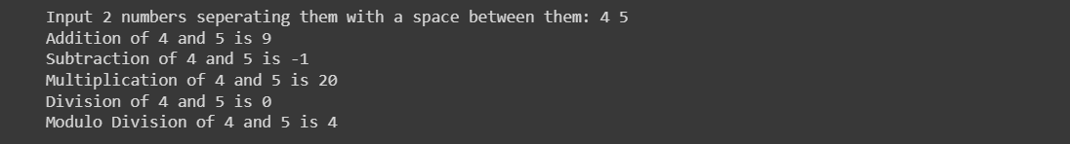

**Problem 2:** To accept a sentence and replace each occurrence of ‘python’ with ‘pythons’.

**Input:** String

**Output:** String

**Solution:**

1. The program takes a string as input from the user.

2. Using the string.replace(sub_string1, sub_string2) method, the word ‘python’ is replaced with ‘pythons’. This method takes an input string and replaces every instance of sub_string1 with sub_string2.

3. The resultant string is printed on the console.

**Code:**

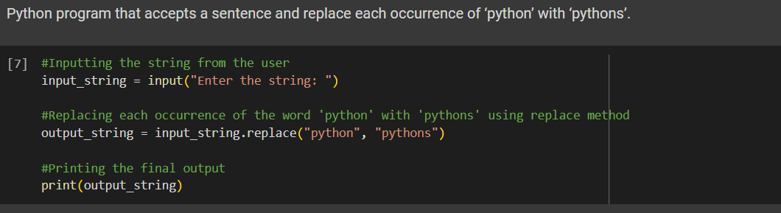

**Output:**



**Problem 3:** To use the if statement conditions to write a program to print the letter grade based on an input class score

**Input:** Integer

**Output:** String

**Solution:**

1. The program takes an integer as input from the user and stores it in the "score" variable.

2. Using if and elif conditions, the value is checked for the criteria for a grade.

3. When the variable matches the condition, the corresponding print function is executed, and the grade is displayed on the console.

**Code:**

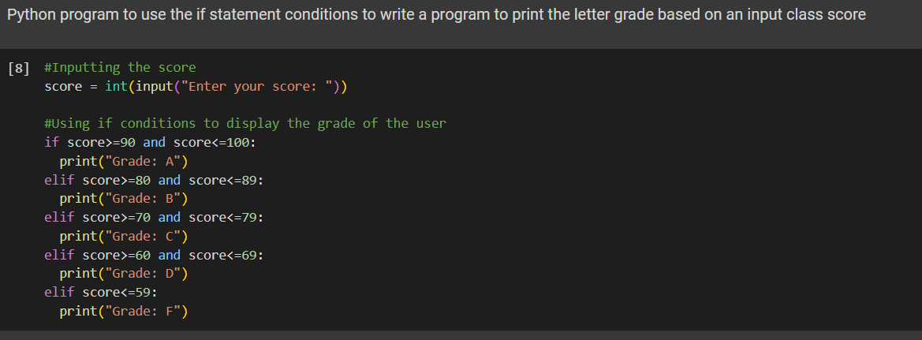

**Output:**

